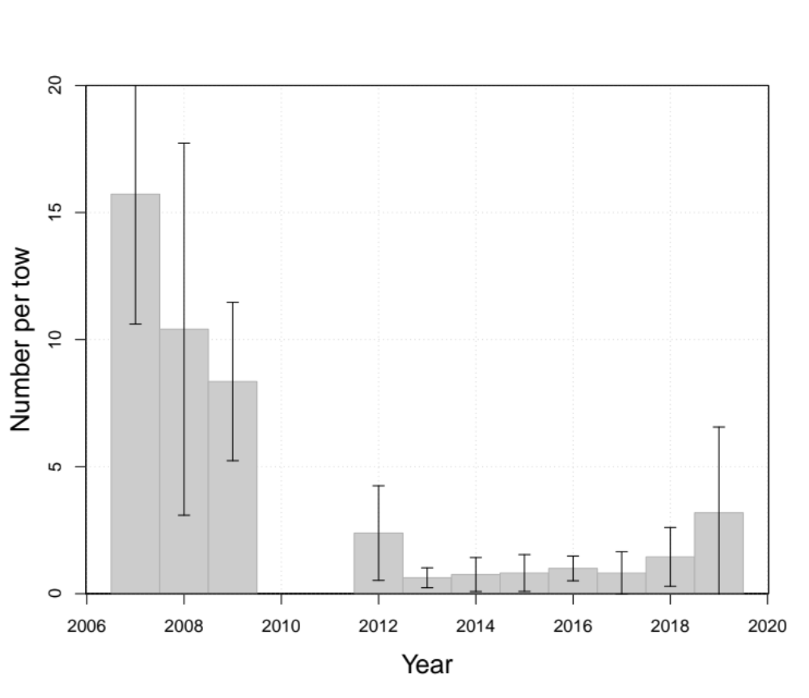
- Abundance indices of gaspereau from the Northumberland Strait trawl survey in average numbers of fish per standardized tow length of 0.625 nautical miles. Error bars show 95% confidence intervals.
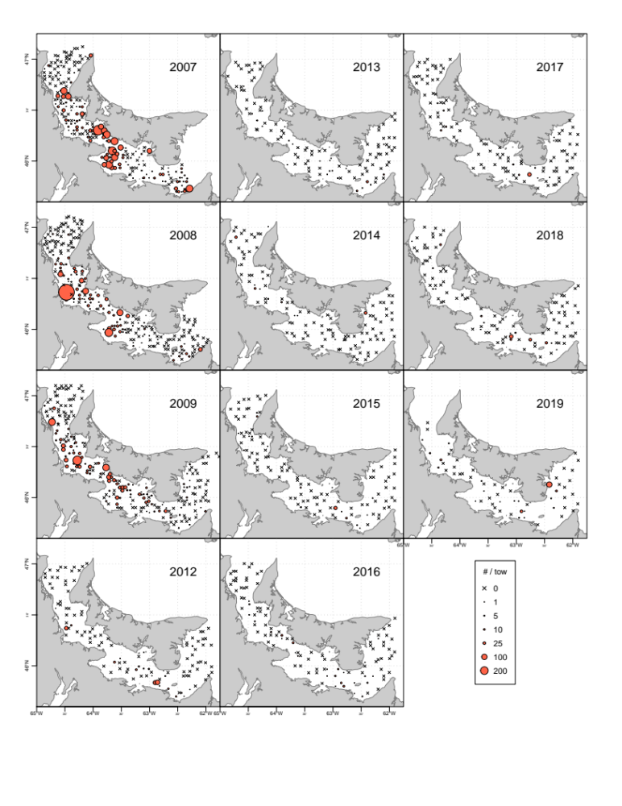

- Spatial distribution of gaspereau catches from the Northumberland Strait trawl survey. Catches were standardized to a standard tow length of 0.625 nautical miles. Catches with no gaspereau are shown as Xs.

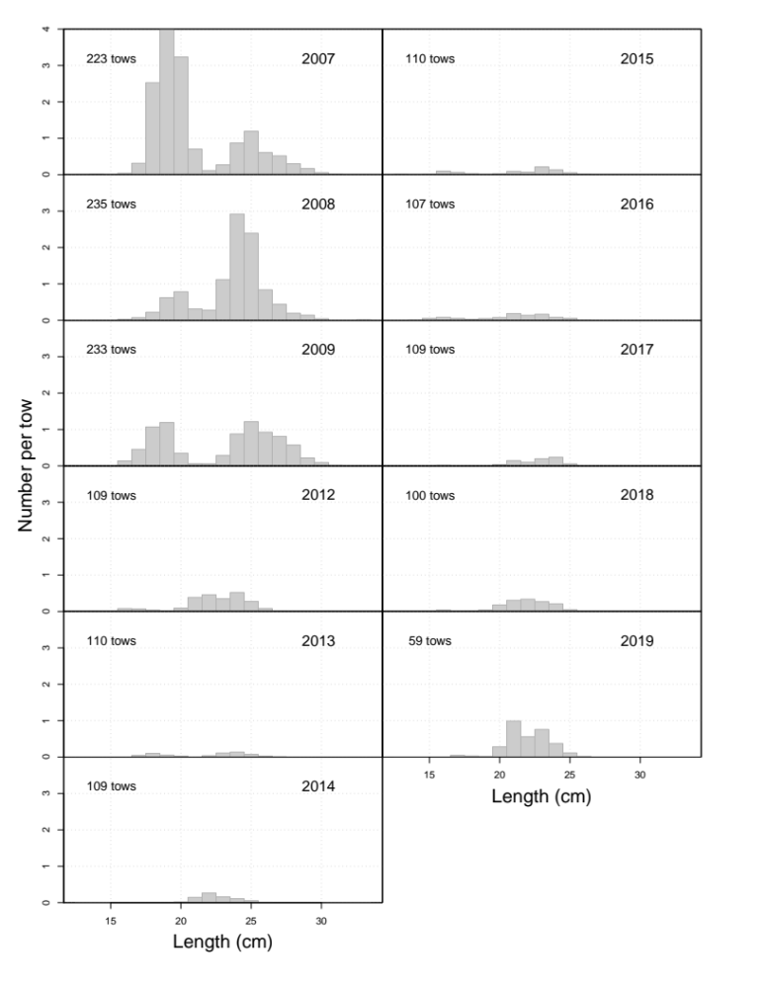
- Length-frequency distributions of gaspereau from the Northumberland Strait trawl survey.

